The code associated with this package are intended free-of-charge for non-profit usages.
Please contact the authors for for-profit usages, modifications and re-distributions.
Please contact the author Xiaotu Ma at Xiaotu.Ma@stjude.org for questions, bugs.
================================================================

This documentation has 4 sections. (A), Downloading and Testing CleanDeepSeq; (B), Running CleanDeepSeq on your own data; (C), Using your own parameter for allele counting; (D), Using your own parameter for visualization; (E), Running deepSNV

A. Downloading and Testing CleanDeepSeq

A1. Download CleanDeepSeq package at xxx
A2. Unzip the package, and go to the folder
A3. Make sure you have samtools working by running below command.
$ samtools view bamdir/Colo829Normal_S5_L001.bam 1:154002369-154002469 | head -n10
You should see reads print on your screen. Consult your system administrator if you have difficulty in this.
A4. Make sure you have R installed by running below command:
$ Rscript code/add_mappability_score.r
You should see below information.
WARNING: ignoring environment value of R_HOME
[1] "Usage: Rscript ~ <geno.ifn> <mappability.ifn> <ofn>"
A5. Make sure you have a working cat by running below command:
$ cat /dev/urandom | tr -dc 'a-z0-9' | head -c 30
You should see a random string of length 30.
A6. With steps A3,A4,A5 passed, you can now run below command:
$ sh go.sh
You should see the progress being print out:
Step 0
Step 1
…
A7. After a few hours, you should see below two files:
cpg.mapp.geno_Q30.counts.Colo829Normal_S5_L001.bam.txt cpg.mapp.geno_Q30.counts.Colo829_TtoN_1to1000_Rep1_S1_L001.bam.txt
shown below are a few rows from file (opened using Microsoft excel) “cpg.mapp.geno_Q30.counts.Colo829_TtoN_1to1000_Rep1_S1_L001.bam.txt”
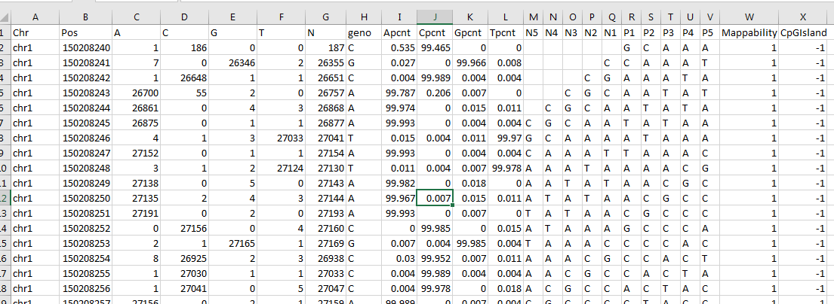
Columns with header “A”, “C”,”G”,”T” are the allele counts; “N” means coverage. “geno” means the genotype, called using 5% as cutoff. Also listed are percentage of A (Apcnt), C (Cpcnt), G (Gpcnt), T (Tpcnt); flanking bases from upstream (N5 through N1) and downstream (P1 through P5). Mappability (1: uniquely mapped) and CpGisland (1: in CpGisland; -1: outside CpGisland) information are also listed.

A8. Different statistical analysis (such as deepSNV analysis) can start from these output files.
A9. You should also see 4 pdf files that look like Fig. 2 and Fig. 3 in the manuscript. These are the visualization of error rates, broken down to 1 flanking bases and 3 flanking bases, respectively.
B. Run CleanDeepSeq on your own data

Please run below command:
$ more go.sh
You should see below:
sh ./code/countbam_slim.sh ./bamdir/Colo829Normal_S5_L001.bam 100000
sh ./code/countbam_slim.sh ./bamdir/Colo829_TtoN_1to1000_Rep1_S1_L001.bam 500000

B.1 So the actual wrapper of the code is ./code/countbam_slim.sh; and it is operating on bam files ./bamdir/Colo829Normal_S5_L001.bam and ./bamdir/Colo829_TtoN_1to1000_Rep1_S1_L001.bam

Note that these bam files have been indexed (i.e., having .bai files; using command samtools index). You need to make sure your own bam files are also indexed.

B.2 The parameters 100000 (for COLO829BL, normal cell line) and 500000 (for 1:1000 dilution) are visualization coverage cutoff (see main text “Deep sequencing data analysis”). Also see A9 above.
B.3 So you can replace the bam file path to your own bam files with above command. You probably want to adjust the visualization coverage cutoff based on your own depth.

C. Using your own parameter for allele counting
Please run below command:
$ head -n29 code/countbam_slim.sh | tail -n10
You should see below output:
QCUTS=30
mCVG=30
readQcut=20
readFcut=0.05
TRIMLEN=5

C1. Here QCUTS means the Phred score cutoff to count alleles. We used 30 here. For HiSeq2500, we suggest using 38, although in our paper we used 30 for simplicity. At cutoff 38, HiSeq2500 had a similar performance as NovaSeq.
C2. mCVG means the minimum coverage that a base pair to be printed to the output file. If you set this parameter to 1, then all covered bases will be output, so that the output file could be huge (such as whole genome data).
C3. readQcut. This is the parameter used to define “poor quality bases”, used in Supplementary Fig. 2d, orange curve.
C4. readFcut. This is the parameter used to define “LQRead” based on “number of poor quality bases” in C3. It is used in Supplementary Fig. 2d, orange curve.
C5. TRIMLEN. This is the parameter to do read end trimming. Related to Fig. 1b.
You can adjust these parameter to do allele counting.

D. Using your own parameter for visualization
Please run below command:
$ tail -n18 code/countbam_slim.sh | head -7
You should see below output:
GenoCvgCut=50
GenoMinMAF=0.05
GenoMinMut=5
Flank=5
oCut=100
Qcut=30

D1. GenoCvgCut means we will do genotyping on bases with >50 coverage.
D2. GenoMinMAF=0.05 means we will make calls whenever an allele has frequncy >0.05, without a testing.
D3. GenoMinMut=5 means there must be at least 5 mutant alleles to make a call.
D4 Flank=5 means we will provide the upstream 5 bases and downstream 5 bases to the output file. Related to the Fig. 3 that used flanking bases.
D5. oCut=100 means we only want to output the bases with coverage >100.
D6. Qcut=30 means we have been using Phred score 30 as cutoff.

E. Running deepSNV
You will need to install R package “deepSNV” from https://bioconductor.org/packages/release/bioc/html/deepSNV.html
We have successfully installed the package using R 3.5.0 under Windows 7 Enterprise.
Please run below command:
$ cd ./proc_deepSNV
$ Rscript go_deepSNV.R
In a few minutes you should be able to see below file:
pdf.test_1v1000.txt.pdf
This will be the testing result of our example data.
The actual program that does testing is below file
test_with_deepSNV.R in folder ./proc_deepSNV

